Analysing Film texts – Warhorse (2011)

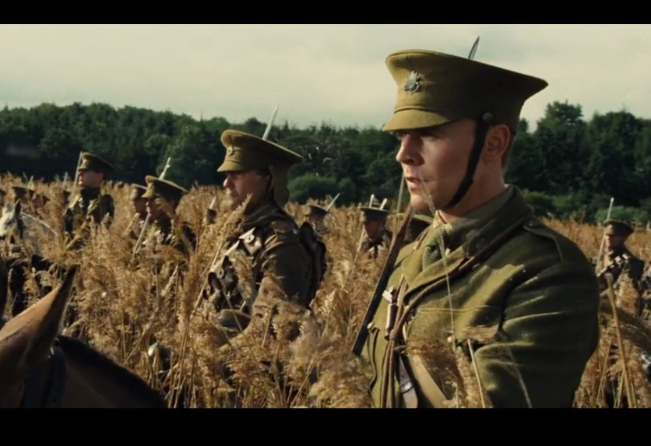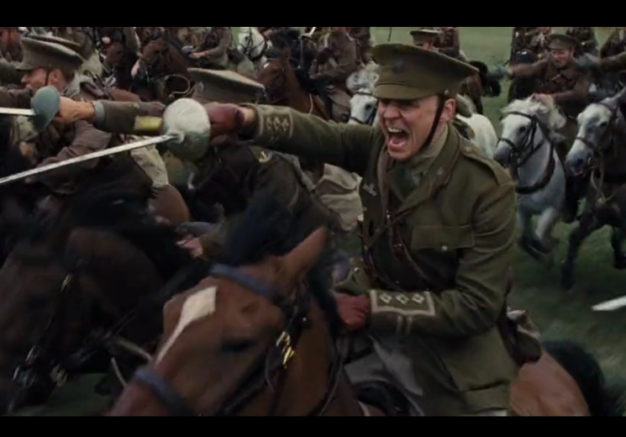
Camera Acting Mise en Scene Editing Lighting Sound
- Watch the scene from Warhorse (2011) pictured above.
- Circle the technical code above that makes the biggest impact.
- In your own words, tell the story of what's happening in the scene.
- Why was the technical code important?
In this scene, the solders ambush and charge the Germanys.
Acting is important because it shows Nicholls fear before he dies.

` 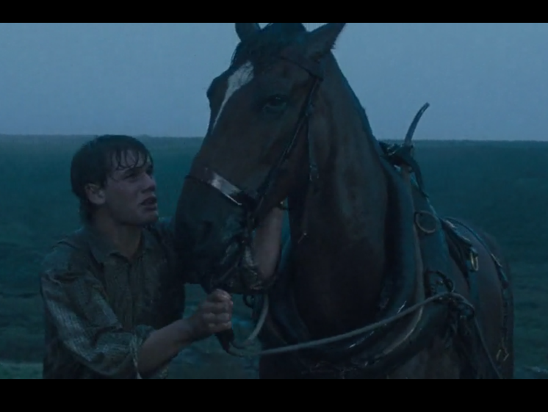 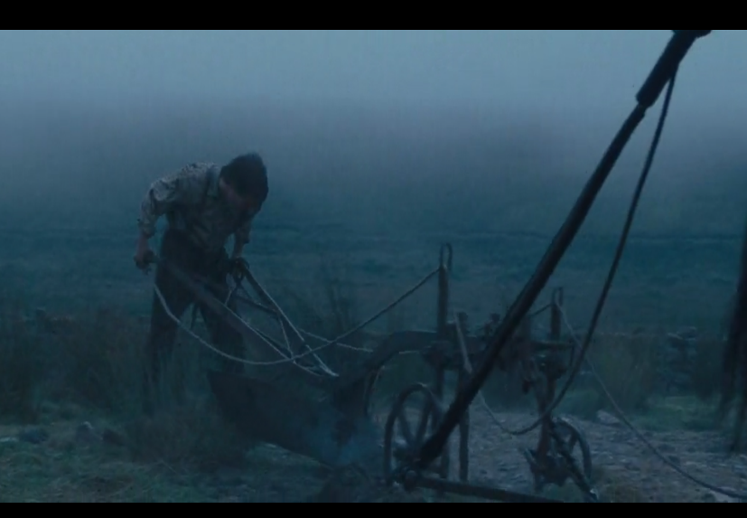
- Camera Acting Mise en Scene Editing Lighting Sound

- Watch the scene from Warhorse (2011) pictured above.
- Circle the technical code above that makes the biggest impact.
- In your own words, tell the story of what's happening in the scene.
- Why was the technical code important?
After failing at cropping the ground, he eventually did it
The mise en scene adding the rain bring out the emotion and his feeling of success

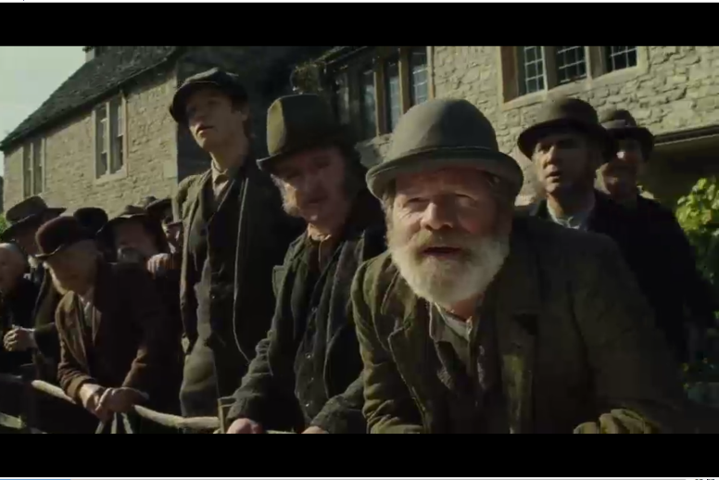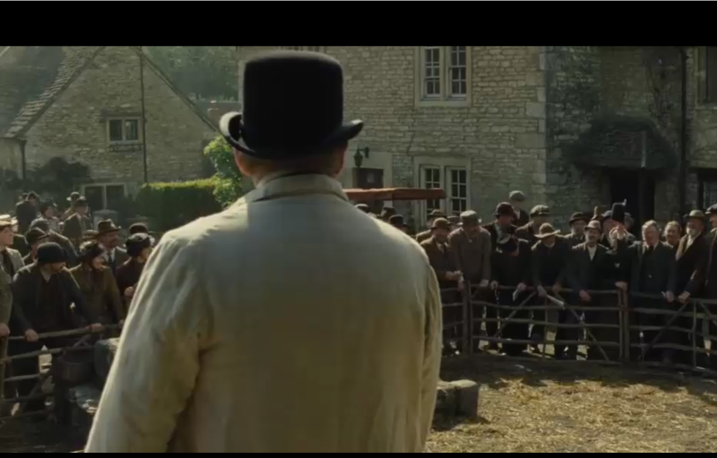
Camera Acting Mise en Scene Editing Lighting Sound
- Watch the scene from Warhorse (2011) pictured above.
- Circle the technical code above that makes the biggest impact.
- In your own words, tell the story of what's happening in the scene.
- Why was the technical code important?

The horse is being auctioned of and people are bidding on the horse.
The Camera was important because the wide shot and over the shoulder shot show the audience the
amount of people there making the audience wonder if they are going to get the horse or not. As well
with the close-up shots showing how much they both want the horse.

